Exploratory Data Analysis Report

Author: João Vitor de Paiva Marcotti

Database: Whisky Casks Auction Database
Available at Kaggle: https://www.kaggle.com/datasets/joaopaivaa/whisky-casks-auction-database

1. X variables exploration

1.1 Numerical X variables
The numerical X variables were analyzed looking at its histograms, as well as its mean and median values.
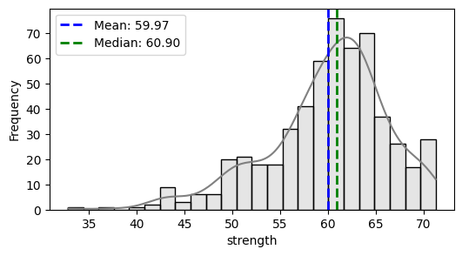
The correlation between these variables was also analyzed, and was found to be of high between:
- Strength and age (inverse);
- RLA and bulk litres and bottles at cask strength;
- Volume 3 months, 6 months and 12 months.
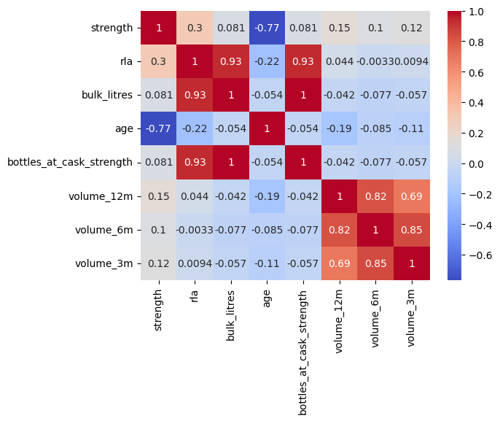
1.2 Categorical X variables
Some variables like distillery have a high number of categories. Therefore, to reduce its cardinality, the categories with at least 2% of the total values were selected, regarding the inflation adjusted hammer price Y variables.
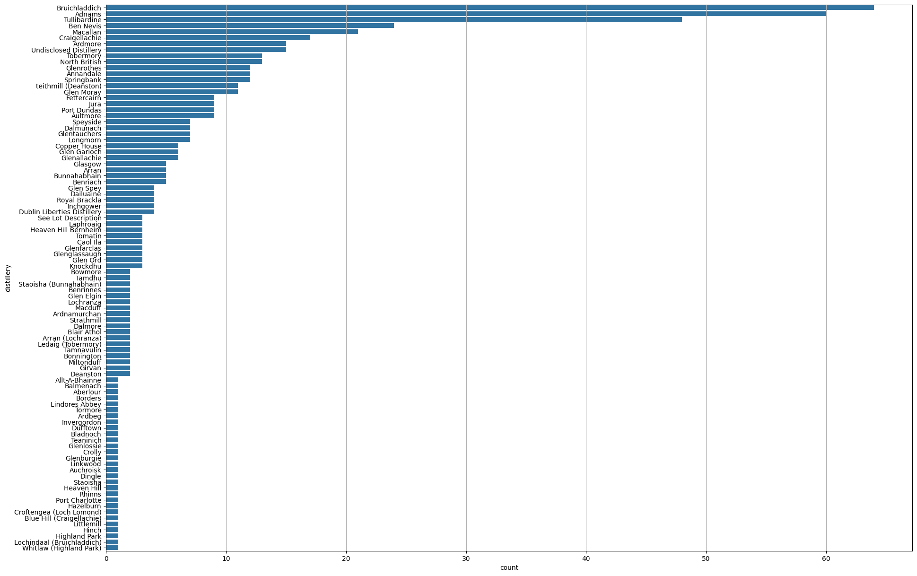
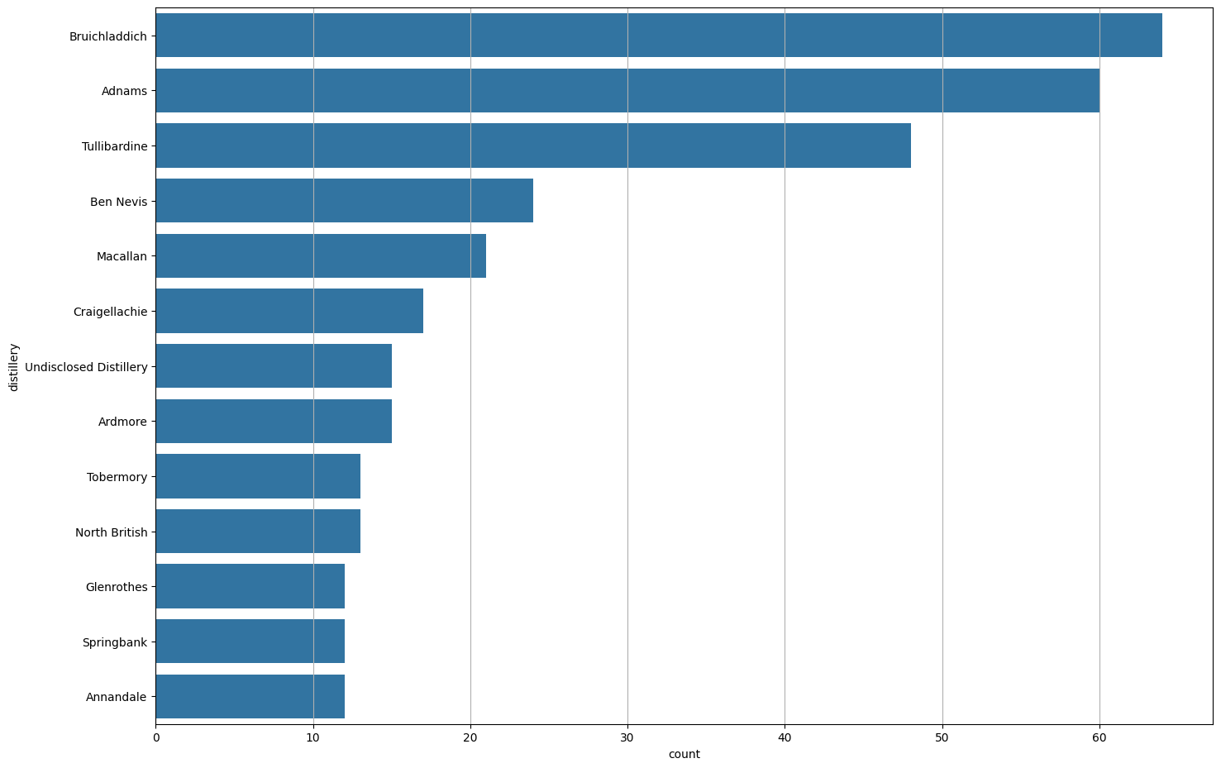
Their box plot distribution was also analyzed, searching for categories with an average Y variable higher/lower than the others.
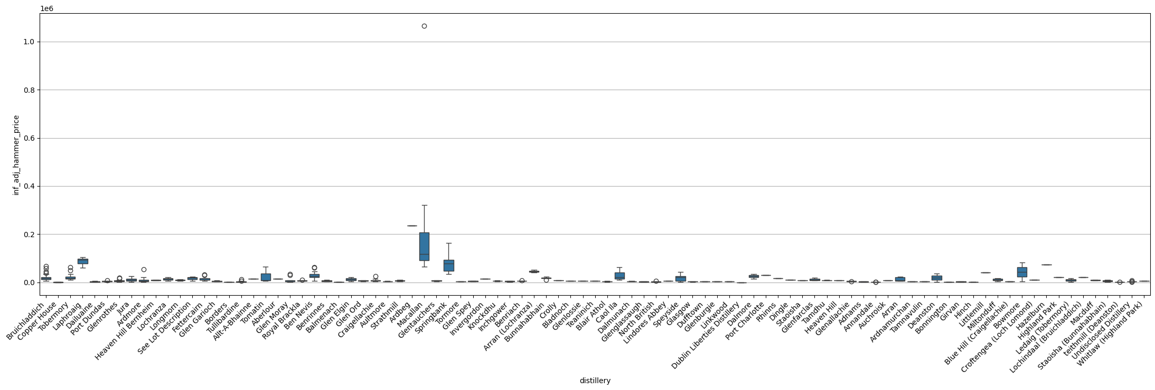
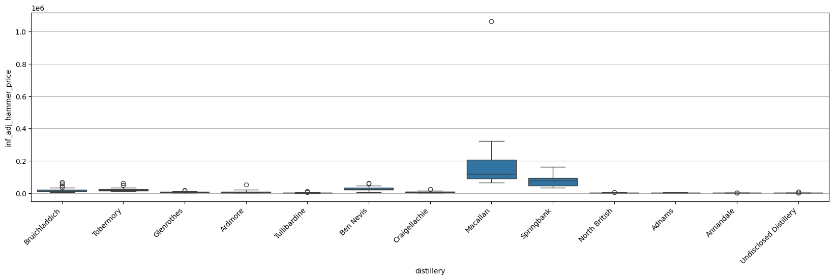
The chart shows that Macallan and Springbank, among the significant categories, have an average price higher than the other distilleries.

2. Y variables normalization
Multiple Y variables were tested:
- Inflation adjusted hammer price
- Inflation adjusted hammer price per litre of alcohol
- Inflation adjusted hammer price per age
- Inflation adjusted hammer price per litre of alcohol per age
Log and Box-Cox transformations were applied to evaluate the best normalization for the Y variables, and evaluated through the Shapiro-Wilk test.
P-value | Interpretation | Conclusion
P > 0.05 | Fail to reject H0 | Data is normally distributed.
P <= 0.05 | Reject H0 | Data is not normally distributed.
Shapiro-Wilk test logic.

3. Relationship between Y and X variables

